Offline Interview Tasks

# Implement the Quarto Game (core logic, or as a console application)

There are several implementations on the [internet](http://quarto.freehostia.com/en/), it is worth to have a few plays to get a good feel of the game.

The implementation does not have to be complete. The user interaction part can be omitted. A core library that implements the game logic is sufficient. No need to design or implement AI.

This can be swapped for a source code of a recent home-project of similar complexity, or partial source code.

# Sump pump control (design only)

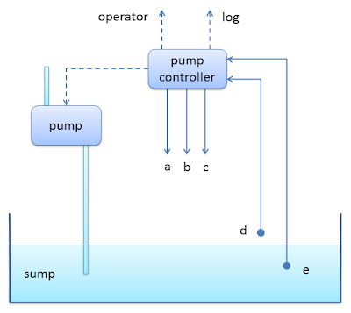

Design a system for the pump controller as described below. Any assumption can be made as long as the core functionality is satisfied. A hand written design drawing is sufficient.

We want to pump water out of a mine sump. We have two water level sensors (D, E). When D goes on, we pump out water until E goes off (this is to realize a form of hysteresis and avoid “bouncing” around a given level).  
There are also a few gas sensors for carbon monoxide, methane and airflow levels (A,B,C). If any of those becomes critical, an alarm must be raised.  
Finally, to prevent explosions, the pump must not be operated when methane is above a certain level.

# Algorithm optimization

Given an array of integers, every element appears twice except for one. Find that single one.  
Optimize the code below and make it less obscure.

int singleNumber(int A[], int n)

{

int min = A[0];

for (int i = 1; i < n; i++)

{

if (A[i] < min)

{

min = A[i];

}

}

int kmin = min + 1;

do

{

int flag = 0;

for (int i = 0; i < n; i++)

{

if (A[i] == kmin)

{

flag = 1; // we cannot use this number

break;

}

}

if (flag == 0) break;

kmin ++;

} while (true);

for (int i = 0; i < n; i++)

{

if (A[i] == kmin)

continue; // has appeared before

int c = 0;

int k = A[i];

A[i] = kmin;

for (int j = i + 1; j < n; j++)

{

if (A[j] == k)

{

c ++;

A[j] = kmin; // mark this so to skip next time

if (c == 1) break; // maximum twice

}

}

if (c != 1) return k;

}

}